**A CRM APPLICATION FOR WHOLESALE RICE MILL**

The Rice Mill  CRM Application is a comprehensive solution designed to streamline and simplify  how much rice per day,how many were sold that rice, and which type of rice all reports send to  owners daily wise. It leverages the power of customer relationship management (CRM) to enhance customer experiences, optimize store operations, and improve overall efficiency in the rice mill factory. This project aims to develop a user-friendly and feature-rich application that addresses the specific needs of a rice mill factory.

Features and Functionality:

Reporting and Dashboards: The application can generate detailed reports and analytics regarding daily how much rice sold and total income per daily, revenue generated, popular amenities, and most buyed customers. Easy to understand the data to the owner, improve resource allocation, and planning future development.

A rollup summary field: This is a field that summarizes data from a child object to a parent object that shares a master-detail relationship. Rollup summary fields can use the COUNT, SUM, MIN, and MAX functions. For example, you could use a rollup summary field to display the total value (amount of rice supplied ) from rice  details on a related supplier.

A cross-object formula field: It  is a formula field that references fields from another object in Salesforce. This type of formula allows users to calculate the total amount from number of rice taken*price/kg  and it displays the total amount I have to pay.

Validation rules: validation rules  also include an error message to display to the user when the rule returns a value of “True” due to an invalid value.so , In this project i gave isblank formula. Isblank formula is used to verify whether it is blank it shows error.

Permission sets: Organization Wide Defaults(OWD) in salesforce is the baseline level of access that the most restricted user should have. Organizational Wide Defaults are used to restrict access. But in our case, we created roles and given the roles in such a way that the owner  can see   employer  and worker  records , and the employer can see the worker  records.

**Introduction to Salesforce**

**Introduction:**

Are you new to Salesforce? Not sure exactly what it is, or how to use it? Don’t know where you should start on your learning journey? If you’ve answered yes to any of these questions, then you’re in the right place. This module is for you.

Welcome to Salesforce! Salesforce is game-changing technology, with a host of productivity-boosting features that will help you sell smarter and faster. As you work toward your badge for this module, we’ll take you through these features and answer the question, “What Salesforce is anyway?”.

What Is Salesforce?

Salesforce is your customer success platform, designed to help you sell, service, market, analyze, and connect with your customers.

Salesforce has everything you need to run your business from anywhere. Using standard products and features, you can manage relationships with prospects and customers, collaborate and engage with employees and partners, and store your data securely in the cloud.

**Activity-1:Creating Developer Account**

Creating a developer org in salesforce.

1. Go to <https://developer.salesforce.com/signup>
2. On the sign up form, enter the following details :
3. First name : REDDY
4. Last name : SREE KEERTHI
5. Email :reddykeerthi993@gmail.com
6. Role : Developer
7. Company : LBRCE
8. County : India
9. Zip code : 523225
10. Username : reddysreekeerthi@trailhead.com

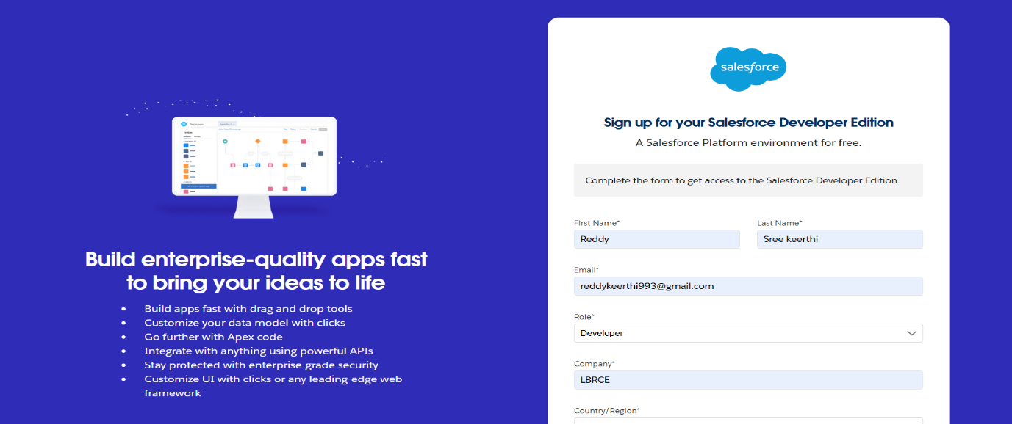

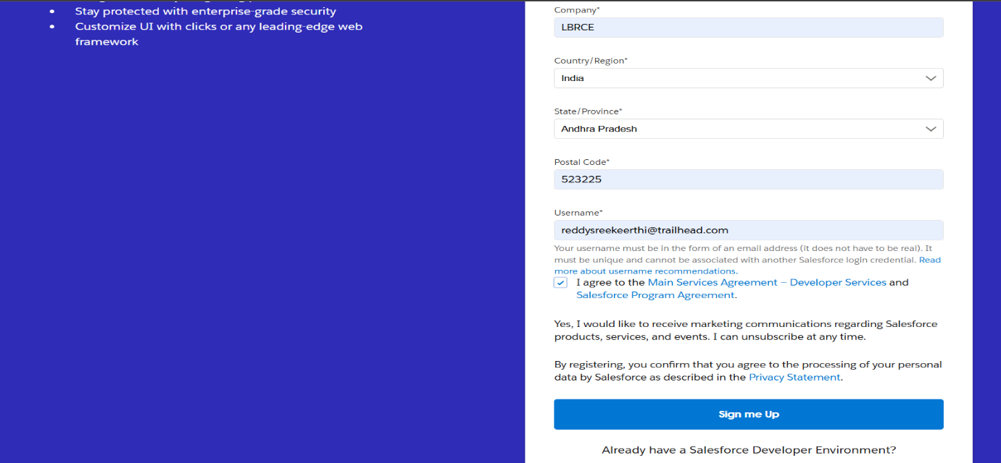

   11.Click on sign me up after filling these.

**Activity-2:Account Activation**

1. Go to the inbox of the email that you used while signing up. Click on the verify account to activate your account. The email may take 5-10mins.

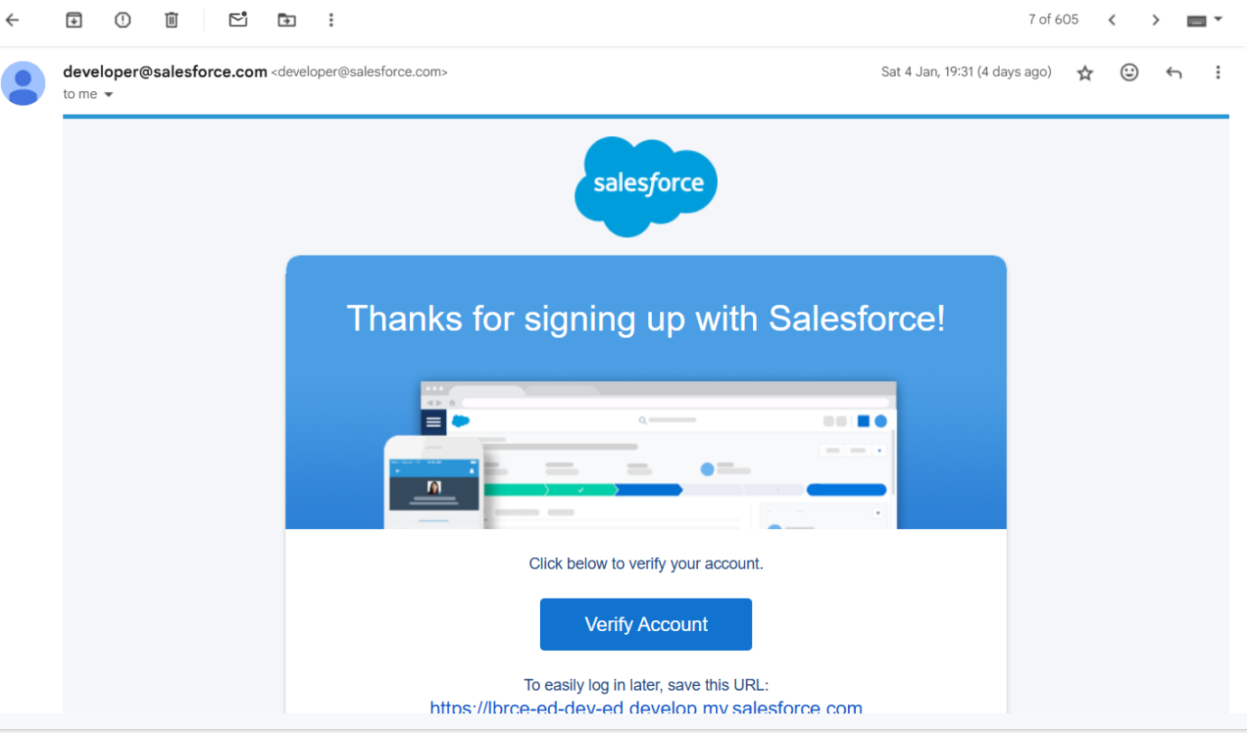

1. Click on Verify Account
2. Give a password and answer a security question and click on change password.
3. Then you will redirect to your salesforce setup page.

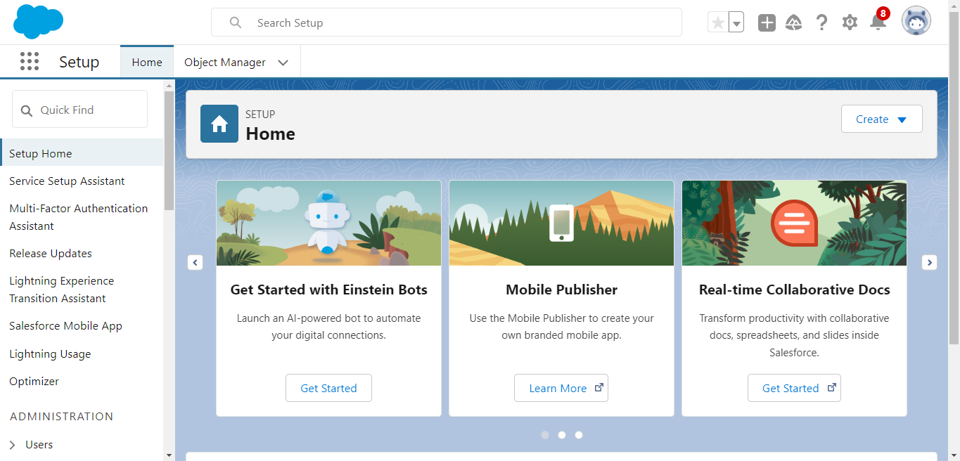

**Object**

What Is an Object?

Salesforce objects are database tables that permit you to store data that is specific to an organization. What are the types of Salesforce objects?

Salesforce objects are of two types:

1. Standard Objects: Standard objects are the kind of objects that are provided by salesforce.com such as users, contracts, reports, dashboards, etc.
2. Custom Objects: Custom objects are those objects that are created by users. They supply information that is unique and essential to their organization. They are the heart of any application and provide a structure for sharing data.

To Navigate to the Setup page:

Click on the gear icon -click setup.

To create an object:

1. From the setup page -
2. Click on Object Manager
3. Click on Create
4. Click on Custom Object.
5. On the Custom object defining page:
6. Enter the label name, plural label name
7. click on Allow reports,
8. Allow search.
9. Click on Save.

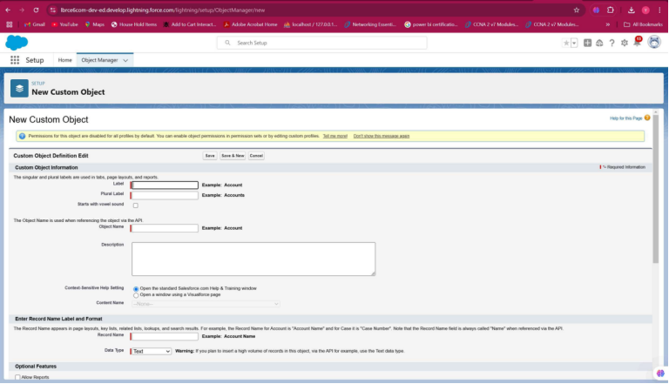\

**1.Create Supplier Object**

To create an object:

1. From the setup page
2. Click on Object Manager
3. Click on Create
4. Click on Custom Object.
5. Enter the label name--supplier
6. Plural label name--supplier
7. Enter Record Name Label, and Format
8. Record Name -- supplier Name
9. Data Type--Text

8.    Click on Allow reports and Track Field History and allow search

9.     Allow search -- Save.

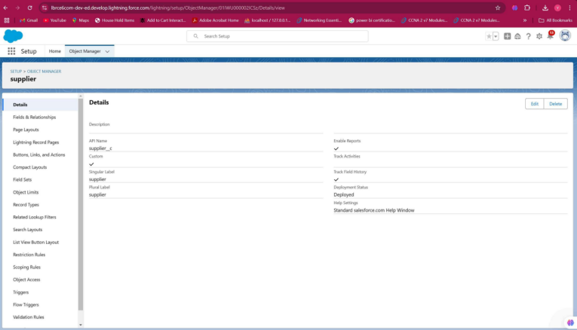

**2.Create Rice mill Object**

To create an object:

1. From the setup page
2. Click on Object Manager
3. Click on Create
4. Click on Custom Object.
5. Enter the label name--rice mill
6. Plural label name--rice mills
7. Enter Record Name Label, and Format

* Record Name--
* Data Type -- Auto Number
* Display Format -- rice-{000}
* Starting number -- 1

8.   Click on Allow reports and Track Field History, Allow Search and Save.

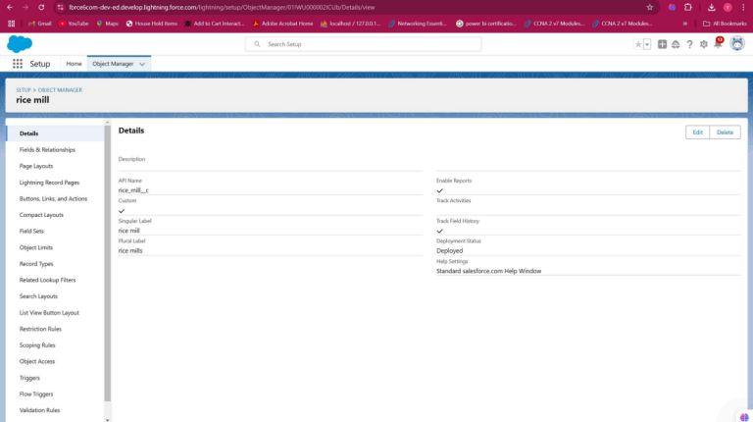

**3.Create consumer Objects**

To create an object:

1. From the setup page
2. Click on Object Manager
3. Click on Create
4. Click on Custom Object.
5. label name >> consumer
6. Plural label name >> consumers
7. Display Format >>  consumers-{000}
8. Starting number >> 1
9. Click on Allow reports and Track Field History, Allow Search and Save.

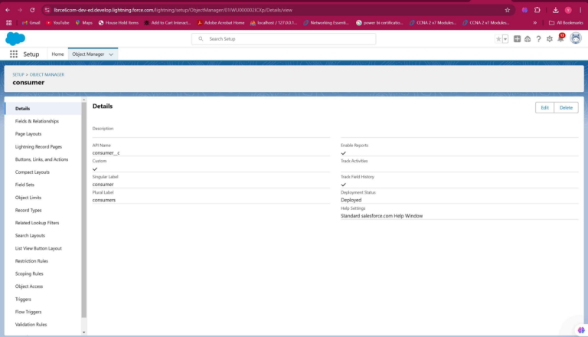

**4.Create rice details Objects**

To create an object:

1. From the setup page
2. Click on Object Manager
3. Click on Create
4. Click on Custom Object.
5. label name >> rice details
6. Plural label name >> rice details
7. Display Format >> rice-{000}
8. Starting Number >>1
9. Click on Allow reports and Track Field History, Allow Search and Save.

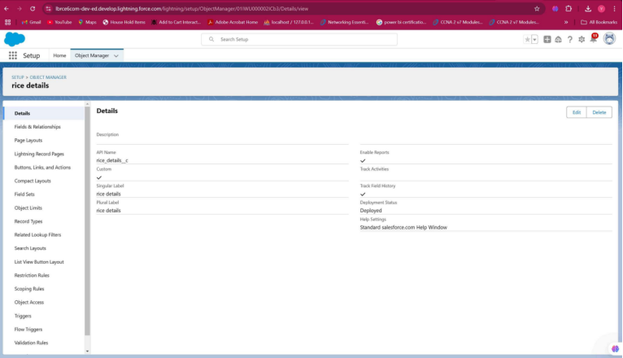

**Tabs**

What is a tab : A tab is like a user interface that is used to build records for objects and to view the records in the objects.

Types of Tabs:

        Custom Tabs

Custom object tabs are the user interface for custom applications that you build in salesforce.com. They look and behave like standard salesforce.com tabs such as accounts, contacts, and opportunities.

Web Tabs

Web Tabs are custom tabs that display web content or applications embedded in the salesforce.com window. Web tabs make it easier for your users to quickly access content and applications they frequently use without leaving the salesforce.com application.

Visualforce Tabs

Visualforce Tabs are custom tabs that display a Visualforce page. Visualforce tabs look and behave like standard salesforce.com tabs such as accounts, contacts, and opportunities.

Lightning Component Tabs

Lightning Component tabs allow you to add Lightning components to the navigation menu in Lightning Experience and the mobile app.

Lightning Page Tabs

Lightning Page Tabs let you add Lightning Pages to the mobile app navigation menu.

Lightning Page tabs don't work like other custom tabs. Once created, they don't show up on the All Tabs page when you click the Plus icon that appears to the right of your current tabs. Lightning Page tabs also don't show up in the Available Tabs list when you customize the tabs for your apps.

**1.Creating a Custom Tab**

To create a Tab:( supplier)

1. Go to setup page
2. type Tabs in Quick Find bar
3. click on tabs
4. New (under custom object tab)
5. Select Object( supplier)
6. Select the tab style
7. Next (Add to profiles page) keep it as default
8. Next (Add to Custom App)  uncheck the include tab .
9. Make sure that the Append tab to users' existing personal customizations is checked.
10. Click save.

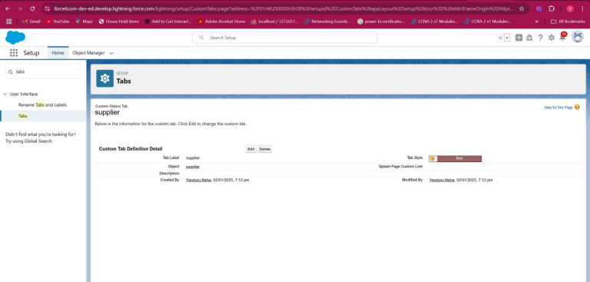

**2.Creating Remaining Tabs**

1. Now create the Tabs for the remaining Objects, they are “ rice mill, consumer , rice details”.
2. Follow the same steps as mentioned in Activity -1 .

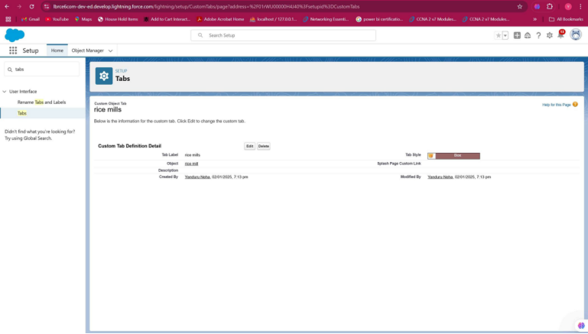

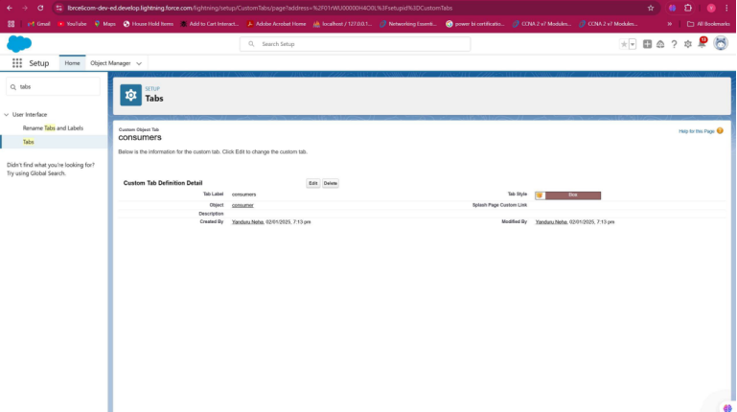

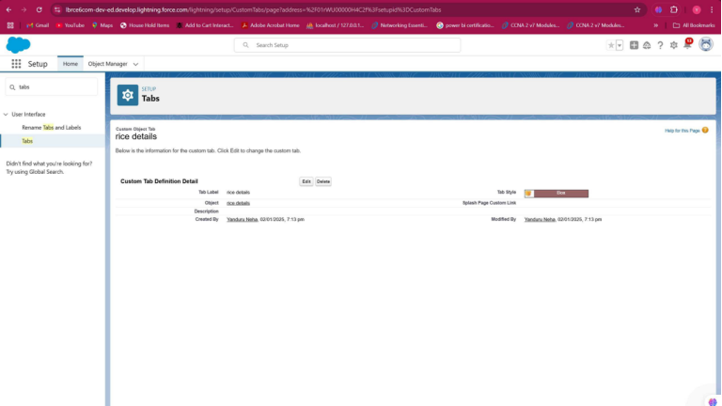

**The Lightning App**

An app is a collection of items that work together to serve a particular function. In Lightning Experience, Lightning apps give your users access to sets of objects, tabs, and other items all in one convenient bundle in the navigation bar.

Lightning apps let you brand your apps with a custom color and logo. You can even include a utility bar and Lightning page tabs in your Lightning app. Members of your org can work more efficiently by easily switching between apps.

**1.Create a Lightning App**

To create a lightning app page:

1. Go to setup page
2. search “app manager” in quick find
3. select “app manager”
4. click on New lightning App.
5. Fill the app name in app details as MY RICE
6. Next  -- (App option page) keep it as default
7. Next -- (Utility Items) keep it as default >> Next.
8. Upload a photo that is related to your app.
9. To add Navigation Item:
10. Select the items (supplier, rice mill, consumer , Rice details ) from the search bar and move it using the arrow button
11. click on Next.
12. To Add User Profiles:
13. Search profiles (System administrator) in the search bar
14. click on the arrow button
15. click on save & finish.

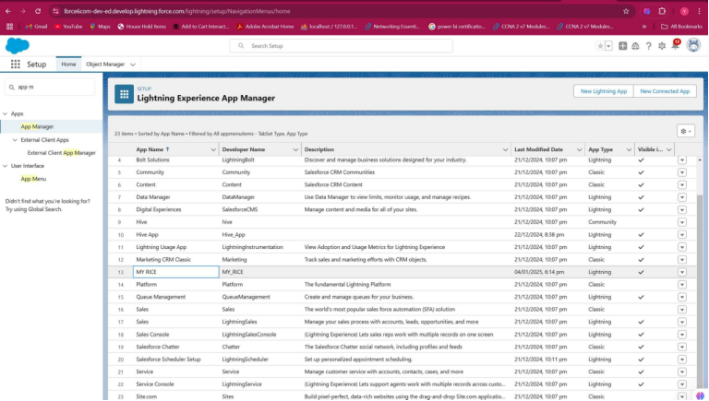

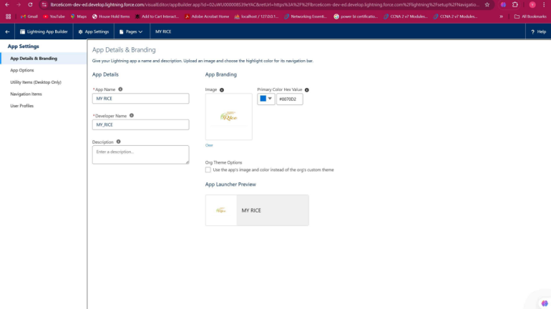

**Fields**

When we talk about Salesforce, Fields represent the data stored in the columns of a relational database. It can also hold any valuable information that you require for a specific object. Hence, the overall searching, deletion, and editing of the records become simpler and quicker.

Types of Fields

1. Standard Fields
2. Custom Fields

Standard Fields:

As the name suggests, the Standard Fields are the predefined fields in Salesforce that perform a standard task. The main point is that you can’t simply delete a Standard Field until it is a non-required standard field. Otherwise, users have the option to delete them at any point from the application freely. Moreover, we have some fields that you will find common in every Salesforce application. They are,

1. Created By

2. Owner

3. Last Modified

4. Field Made During object Creation

Custom Fields:

On the other side of the coin, Custom Fields are highly flexible, and users can change them according to requirements. Moreover, each organizer or company can use them if necessary. It means you need not always include them in the records, unlike Standard fields. Hence, the final decision depends on the user, and he can add/remove Custom Fields of any given form.

**1.Creating the number field in rice details object**

Creating the number field in rice details object

1. Go to the setup page >> click on object manager >> From drop down click edit for  rice details object
2. Click on fields & relationship >> click on New.
3. Select Data type as “Number” and click Next.
4. Given the Field Label as “ rice distributed ” and length as “ 5 ”.
5. Field Name will be auto populated, and click on Next- Next >> Save.

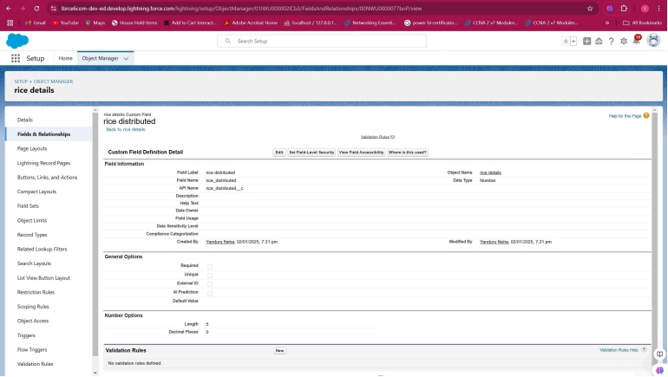

**2.Creating Junction Object**

A Junction  object is a custom object that serves as a bridge between two related objects in a  many-to-many relationship. It allows you to create a relationship between records of two different objects by creating a many-to-many relationship model.

Creating junction object as rice details with supplier & rice mill

To create junction object

    1.Go to the setup page >> click on object manager >> From drop down click edit for  rice details    object

1. Click on fields & relationship - click on New.
2. Select “Master-Detail relationship” as data type and click Next.
3. Select the related object “ supplier ” and click next.
4. Give Field Label as “supplier Name” and click Next.
5. Next >> Next >> Save & New.
6. Follow the same steps from  1 to 3.
7. Select the related object “ rice mill ” and click Next.
8. Give Field Label as “rice mill 1(one)” and click Next.
9. Next >> Next >> Save.

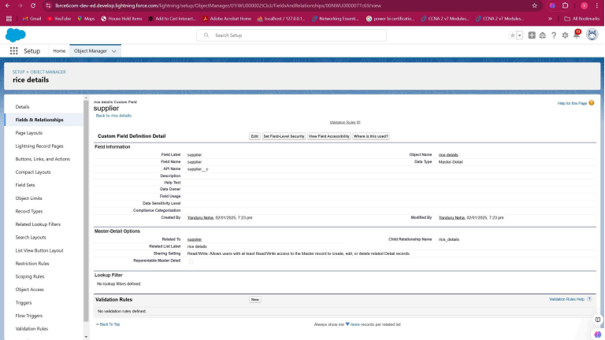

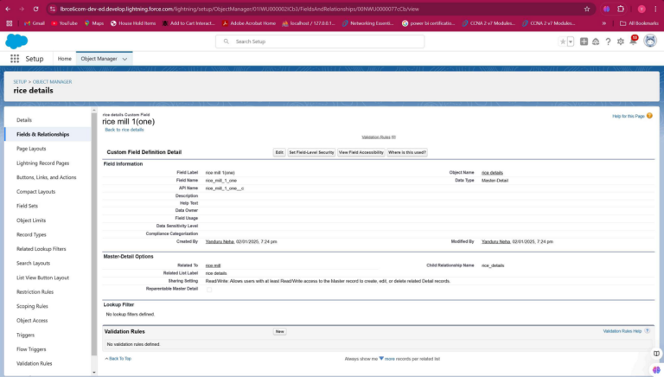

**3.Creating a Master-Detail Relationship**

master-detail relationship is a type of relationship between two objects where the master object controls certain behaviors and settings of the detail object. Here are a few use cases that demonstrate the use of master-detail relationships

Creating Master-Detail Relationship between consumer & rice mill Object

To Create a Master-Detail relationship

1. Go to the setup page >> click on object manager >> From drop down click edit for  consumer object.
2. Click on fields & relationship >> click on New.
3. Select “Master-Detail relationship” as data type and click Next.
4. Select the related object “ rice mill”.
5. Give Field Label as “rice mill name” and click Next.
6. Next >> Next >> Save.

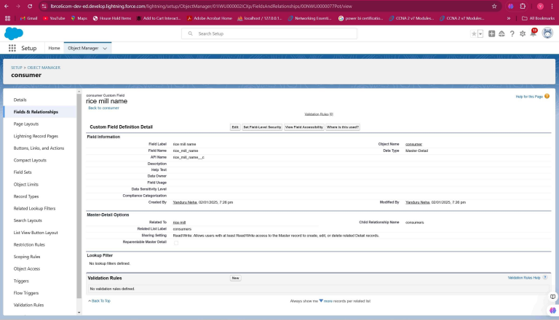

**4.Creating the Roll-up Summary**

A rollup summary field is a field that summarizes data from a child object to a parent object that shares a master-detail relationship. Rollup summary fields can use the COUNT, SUM, MIN, and MAX functions. For example, you could use a rollup summary field to display the total value (amount of rice supplied ) from rice  details on a related supplier.

Creating the Roll-up summary field on supplier & rice mill Objects.

1. Go to setup >> click on Object Manager >> type object name(supplier) in search bar >> click on the object.
2. Now click on “Fields & Relationships” >> New
3. Select the data type as “Rollup summary ”,and click Next.
4. Give the Field label as “ sum of rice distributed ”,Field Name will be Auto generated, and click Next.
5. Select the summarized object as “ rice details ”.
6. Select the Rollup type as “sum”.
7. Select the field to aggregate as “ rice distributed ”, and click Next >>Next >>Save.
8. Follow the same steps for the rice mill Object from 1 to 3
9. Give the Field label as “ rice distributed to shops ”,Field Name will be Auto generated, and click Next.
10. Select the summarized object as “ rice details ”.
11. Select the Rollup type as “sum”.
12. Select the field to aggregate as “ rice distributed ”, and click Next >> Next >> Save.
13. Note : create the field as  “ rice taken by shops in kgs”  using number datatype in consumer object
14. Follow the same steps for the rice mill Object from 1 to 3
15. Give the Field label as “ rice taken ”,Field Name will be Auto generated, and click Next.
16. Select the summarized object as “ consumer”.
17. Select the Rollup type as “sum”.
18. Select the field to aggregate as “ rice taken in shops ”, and click Next >> Next >> Save.

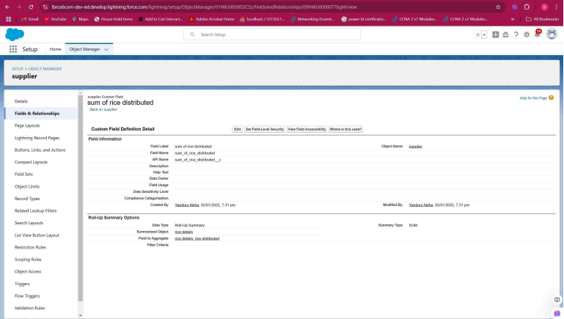

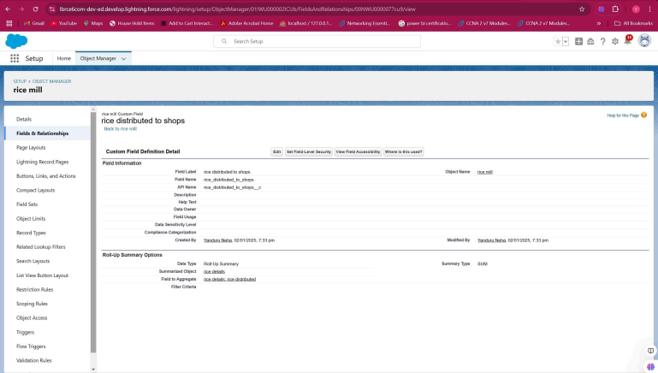

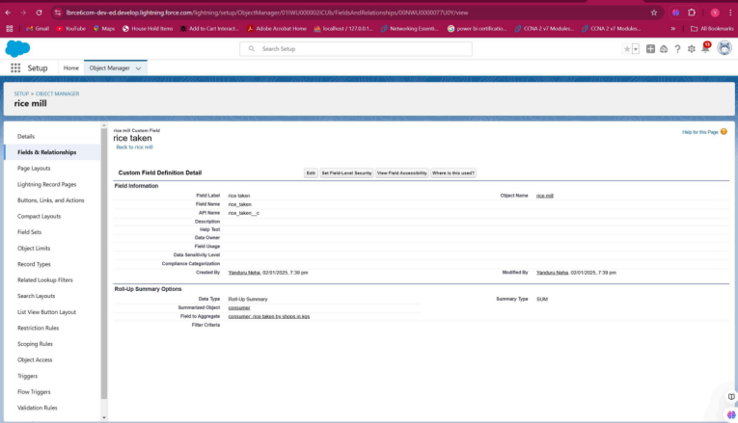

**5.Creating Fields in Objects**

Creating the number field in rice details object

1. Go to the setup page >> click on object manager >> From drop down click edit for  rice details object.
2. Click on fields & relationship >> click on New.
3. Select Data type as “master detail” and click Next.
4. Given the Field Label as “ supplier  name ” and length as “ 5 ".
5. Field Name will be auto populated, and click on Next>> Next >>Save.

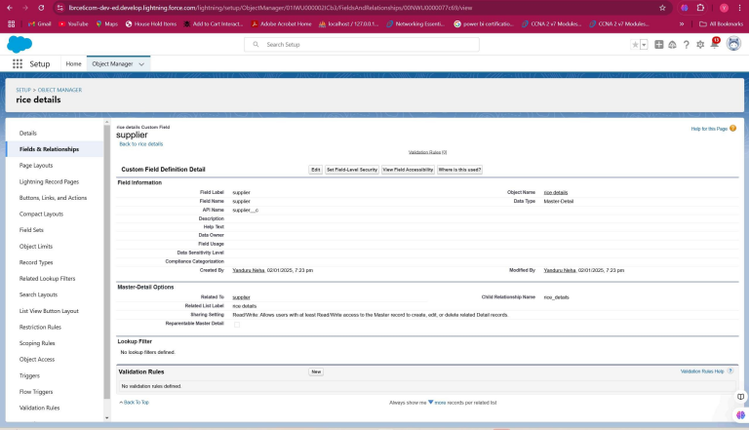

**6.Creating Fields in rice mill Objects**

Creating the number field in rice details object

1. Go to the setup page >> click on object manager >> From drop down click edit for  rice details object.
2. Click on fields & relationship >> click on New.
3. Select Data type as “Number” and click Next.
4. Given the Field Label as “ rice price/kg ” and length as “ 5 ”
5. Field Name will be auto populated, and click on Next>> Next >>Save.

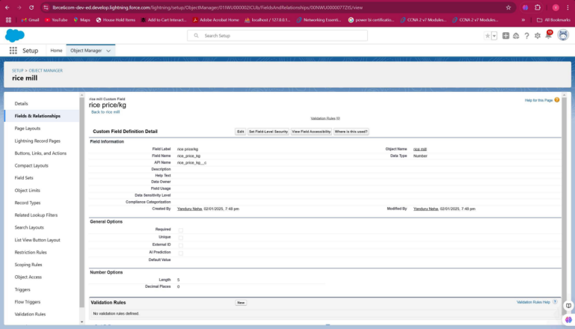

**7.Creating Fields in consumer Objects**

1. Go to setup >> click on Object Manager >> type object name(consumer) in search bar >> click on the object.
2. Click on fields & relationship >> click on New.

First name:

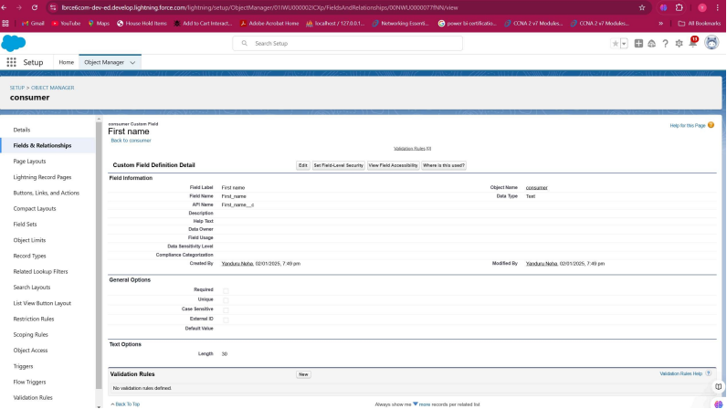

Last name:

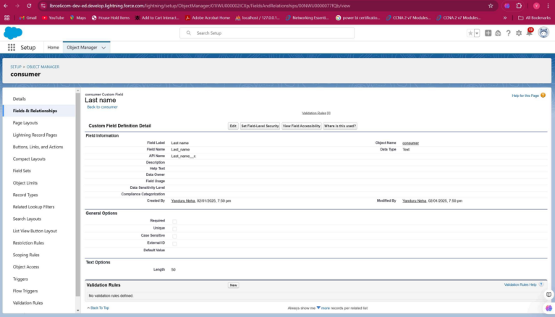

Phone number:

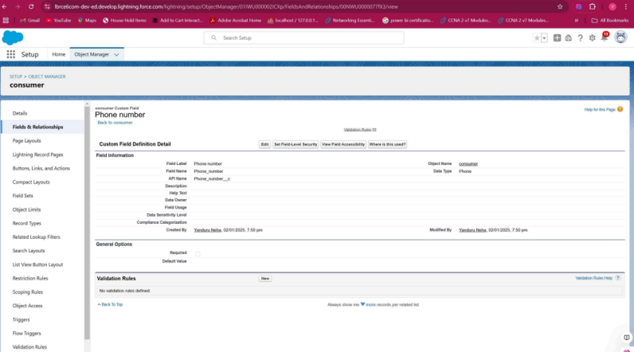

Email:

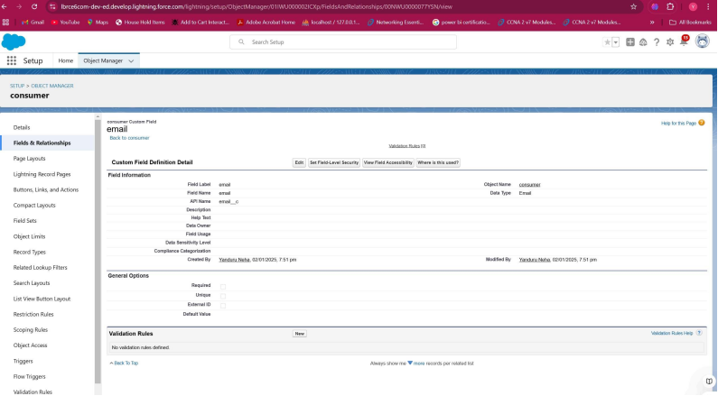

Rice taken by shops:

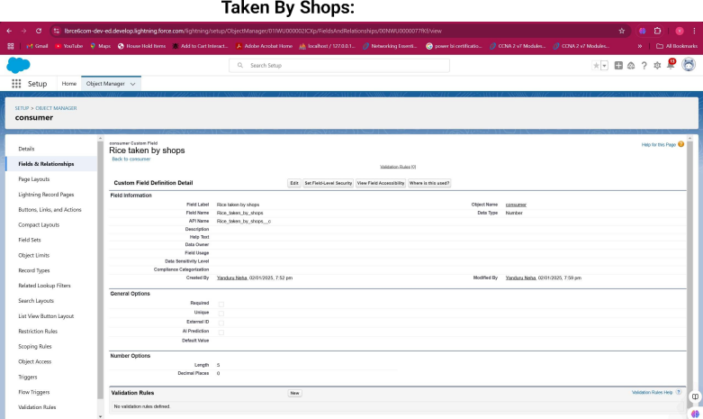

Rice type:

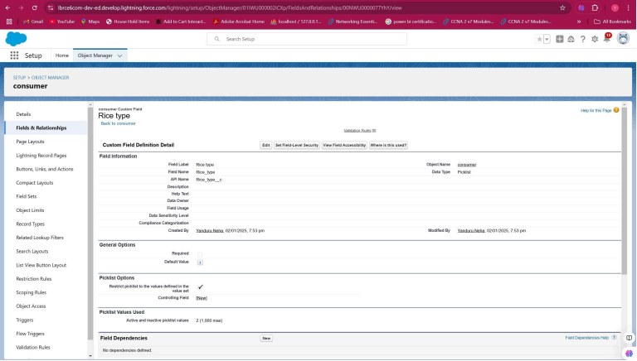

Mode of payment :

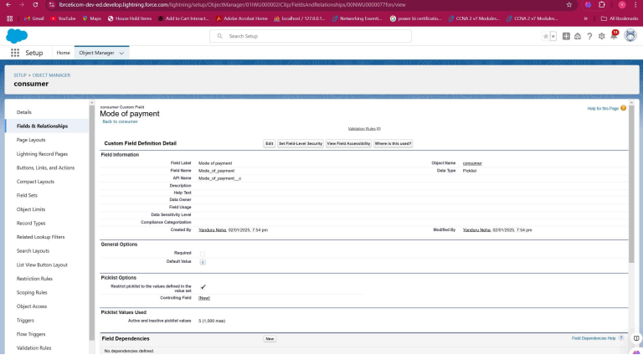

**8**.**Creating Cross Object Formula Field in consumer Object**

A cross-object formula field is a formula field that references fields from another object in Salesforce. This type of formula allows users to calculate and display data from multiple objects on a single record.

Note : check whether the fields mentioned in the formula field are created or not , if not go to activity 9 and create those fields mentioned in consumer object.

1. Go to setup >> click on Object Manager >> type object name(consumer) in search bar >> click on the object.
2. Click on fields & relationship >> click on New.
3. Select Data type as “Formula” and click Next.
4. Give Field Label and Field Name as “Amount Paid ” and select formula return type as “Number” and click next.
5. Insert fields formula should be :

  rice_taken_by_shops__c  * rice_mill_name__r.rice_price_kg__c

1. Under Advanced Formula write down the formula and click “Check Syntax” and Save.

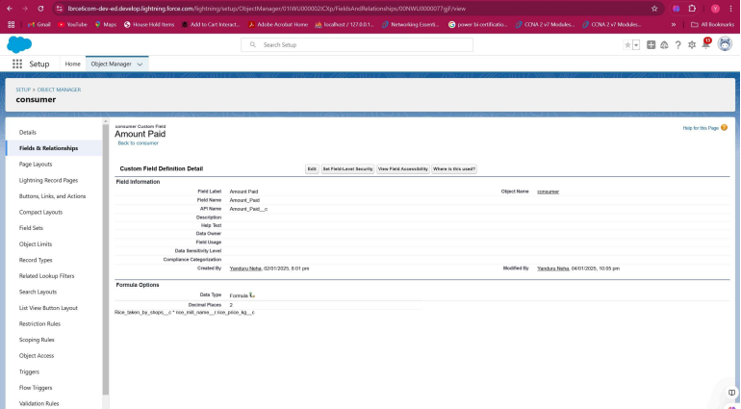

1. Creating the Formula field in consumer Object

Note : check whether that the fields that mentioned in the formula field are created are not , if not go to activity 9 and create that fields mentioned in consumer object

1. Go to setup >> click on Object Manager >> type object name(consumer) in search bar >> click on the object.
2. Click on fields & relationship >> click on New.
3. Select Data type as “Formula” and click Next.
4. Give Field Label and Field Name as “Consumer Name” and select formula return type as “TEXT” and click next.
5. Insert field formula should be : First_Name__c   + ' ' +  Last_Name__c
6. click “Check Syntax” and Save.

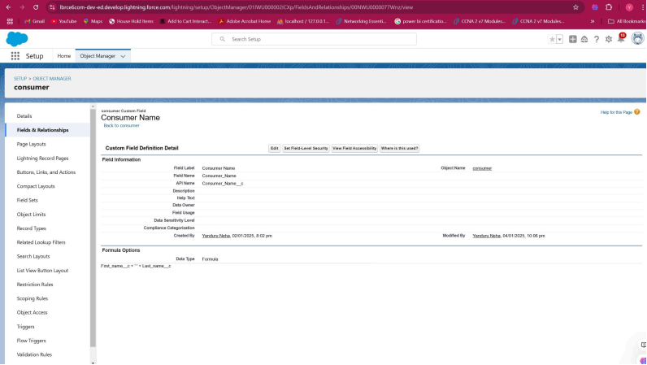

**9.Creating the validation rule**

Improve the quality of your data using validation rules. Validation rules verify that the data a user enters in a record meets the standards you specify before the user can save the record. A validation rule can contain a formula or expression that evaluates the data in one or more fields and returns a value of “True” or “False”. Validation rules also include an error message to display to the user when the rule returns a value of “True” due to an invalid value.

Creating the validation rule for phone number field in consumer  object

Note : check whether the fields mentioned in the formula field are created or not , if not go to activity 9 and create those fields mentioned in consumer object.

1. Go to the setup page >>click on object manager >> From drop down click edit for  consumer object.
2. Click on the validation rule >> click New.
3. Enter the Rule name as “Phonenumberoremailblankrule ”.
4. Enter the description as “phone number and email number should not be blank”.
5. Enter the formula as “OR( ISBLANK( phone_number__c ) , ISBLANK( email__c ) )” and check the syntax.
6. Under the error message write as”please fill in your phone number.”
7. Select error location “top of page”.
8. Save the validation rule.

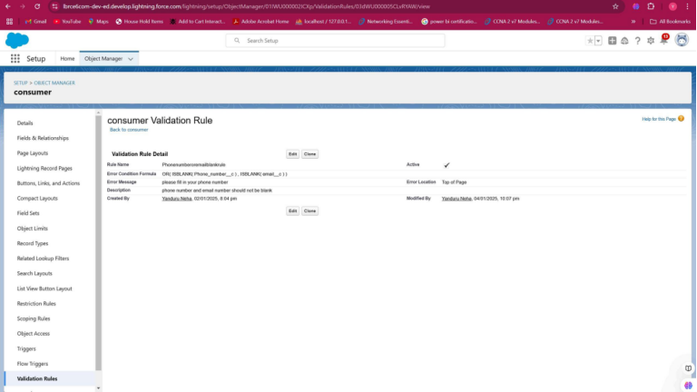

**Page layouts**

Page Layout in Salesforce allows us to customize the design and organize detail and edit pages of records in Salesforce. Page layouts can be used to control the appearance of fields, related lists, and custom links on standard and custom objects' detail and edit pages.

**1.creating the page layout**

To Create a Page layout:

1. Go to Setup >> Click on Object Manager >>Search for the object (consumer) >> From drop down select the object and click on it.
2. Click on Page layout >> Click on New.
3. Select the existing page layout, and give the page layout name as “consumer layout”, and click save.
4. Drag and drop the section field to consumer details and create the section.
5. Enter the section name as “Personal details”, - click Ok.
6. Now drag the fields to this section that mentioned , they are

* First name , last name , consumer name , phone number, email, rice mill name.

7.    Follow the same process for another two sections as shown above , they are

8.    One section is “ rice details ” , drag the fields that are

* Rice taken by shop, rice type.

9.   Another section is “Receipt details ”, and drag the fields that are

* Mode of payment , Amount paid.

10.   Then , Click save.

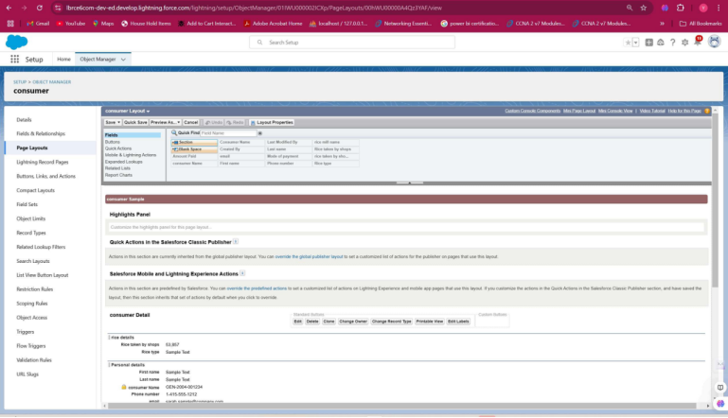

**Profiles**

A profile is a group/collection of settings and permissions that define what a user can do in salesforce. Profile controls “Object permissions, Field permissions, User permissions, Tab settings, App settings, Apex class access, Visualforce page access, Page layouts, Record Types, Login hours & Login IP ranges. You can define profiles by the user's job function. For example System Administrator, Developer, Sales Representative.

Types of profiles in salesforce

1. Standard profiles:

By default salesforce provides below standard profiles.

* Contract Manager
* Read Only
* Marketing User
* Solutions Manager
* Standard User
* System Administrator.

We cannot deleted standard ones

Each of these standard ones includes a default set of permissions for all of the standard objects available on the platform.

1. Custom Profiles:

Custom ones defined by us.

They can be deleted if there are no users assigned with that particular one.

**1.owner Profile**

To create a new profile:

1. Go to setup >> type profiles in quick find box >> click on profiles >> clone the desired profile (Standard User) >>enter profile name (owner) >> Save.
2. Scroll down to Custom Object Permissions and Give access permissions for consumers, rice details , rice mill and suppliers objects as mentioned in the below diagram.
3. Give access and save it.

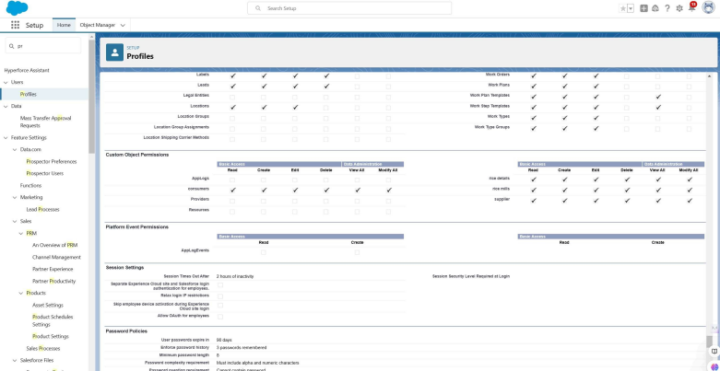

**2.employer Profile**

1. Go to setup >> type profiles in quick find box >>click on profiles >> clone the desired profile (Standard Platform User) >> enter profile name (employer) >> Save.
2. While still on the profile page, then click Edit.
3. Select the Custom App settings as default for the rice mill.
4. Scroll down to Custom Object Permissions and Give access permissions for consumer, rice details , rice mill  and suppliers  objects as mentioned in the below diagram.
5. And click save.

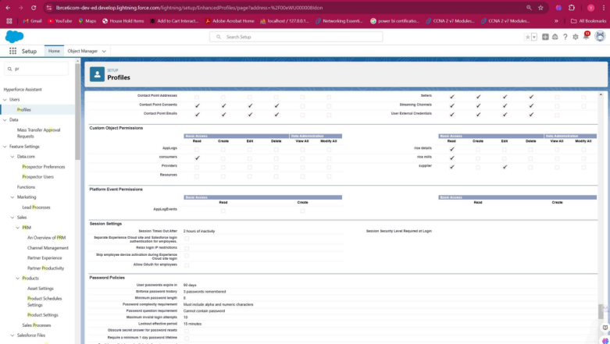

**3.worker Profile**

1. Go to setup >> type profiles in quick find box >> click on profiles >> clone the desired profile (Standard Platform User) >> enter profile name (worker) >> Save.
2. While still on the profile page, then click Edit.
3. Select the Custom App settings as default for the rice mill.
4. Scroll down to Custom Object Permissions and Give access permissions for consumer, rice details , rice mill  and suppliers objects as mentioned in the below diagram.
5. And click save.

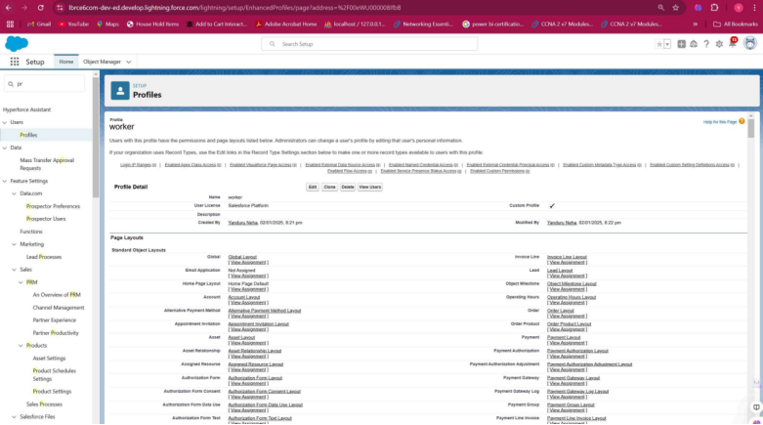

**Role & Role Hierarchy**

A role in Salesforce defines a user's visibility access at the record level. Roles may be used to specify the types of access that people in your Salesforce organization can have to data. Simply put, it describes what a user could see within the Salesforce organization.

**1.Creating owner Role**

Creating owner Role:

1. Go to quick find >> Search for Roles >> click on set up roles.
2. Go to quick find >> Search for Roles >> click on set up roles.
3. Click on Expand All and click on add role under whom this role works.
4. Give Label as “owner” and Role name gets auto populated. Then click on Save.
5. Click and save it.

**2.Creating employer roles**

Creating another two roles under manager

1. Go to quick find >>Search for Roles >>click on set up roles.
2. Click plus on CEO role, and click add role under owner.
3. Give Label as “employer” and Role name gets auto populated. Then click on Save.
4. Repeat the same steps, for another role.
5. Click plus on CEO role, and click plus on owner, and click add role under employer.
6. give Label as “worker” and Role name gets auto populated. Then click on Save.

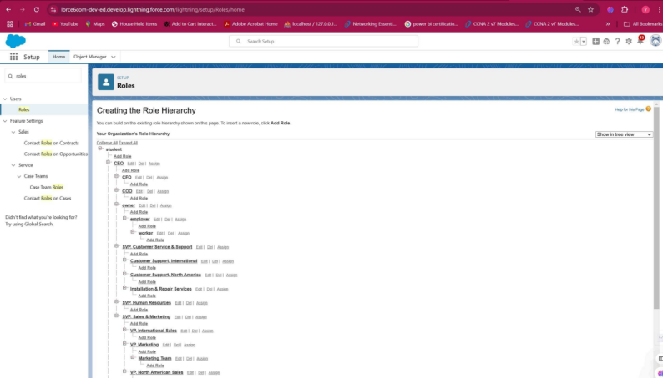

**Users**

A user is anyone who logs in to Salesforce. Users are employees at your company, such as sales reps, managers, and IT specialists, who need access to the company's records. Every user in Salesforce has a user account. The user account identifies the user, and the user account settings determine what features and records the user can access.

**1.Create User**

1. Go to setup >> type users in quick find box >> select users >> click New user.
2. Fill in the fields
3. First Name : vicky
4. Last Name : y
5. Alias : vy
6. Email id : abc@gmail.com
7. Username : abc@gmail.com
8. Nick Name : vicky
9. Role : owner
10. User license : Salesforce
11. Profiles : owner.
12. Save it.

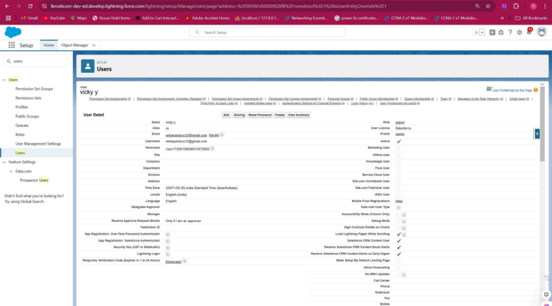

**2.creating another users**

1. Go to setup >> type users in quick find box >> select users >> click New user.
2. Fill in the fields
3. First Name : ram
4. Last Name : ram
5. Alias : rram
6. Email id : abc@gmail.com
7. Username : abcd@gmail.com
8. Nick Name : ram
9. Role : employer
10. User license : Salesforce platform
11. Profiles : standard platform user.

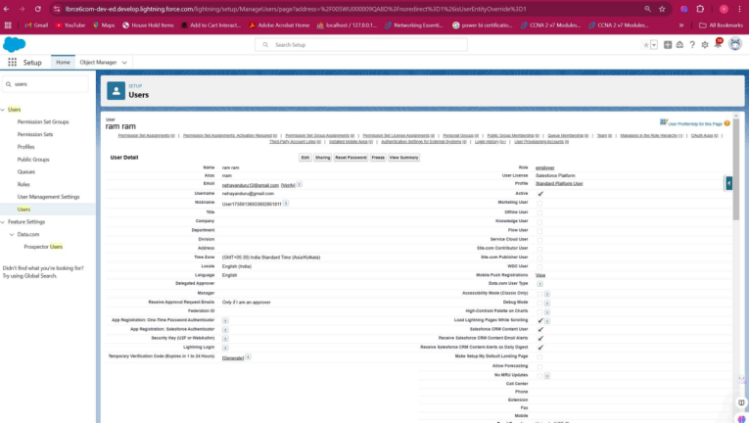

**3.Create Another User**

1. Go to setup ? type users in quick find box ? select users ? click New user.
2. Fill in the fields
3. First Name : ragu
4. Last Name : raj
5. Alias : raguraj
6. Email id : abc@gmail.com
7. Username : abcde@gmail.com
8. Nick Name :ragu.
9. Role : worker
10. User license : Salesforce platform
11. Profiles : standard platform user.

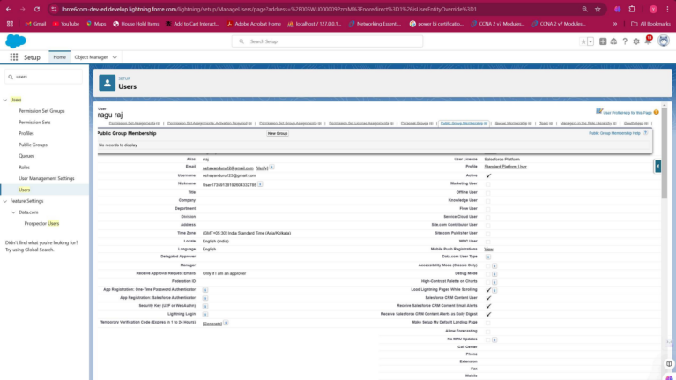

**Permission sets**

A permission set is a collection of settings and permissions that give users access to various tools and functions. Permission sets extend users’ functional access without changing their profiles and are the recommended way to manage your users’ permissions.

**1.Creating OWD setting.**

1. Go to setup >> type “sharing settings ” in quick search >> Click edit.
2. Scroll down, change the default internal access to “ public read-only” for rice mill and supplier  object.
3. Click save.
4. Extra information, By these every profile has their own access, according to their profile.
5. But in our case we created roles and given the roles in such a way that the owner  can see   employer  and worker  records , and the employer can see the worker  records.

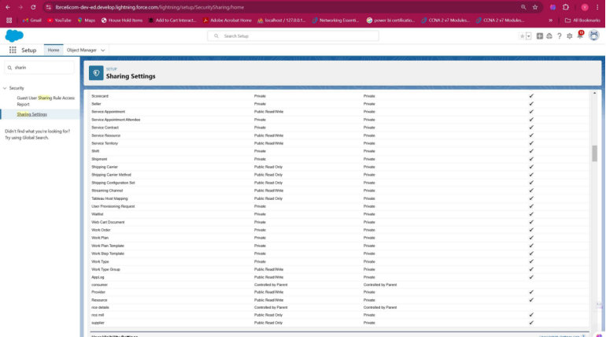

**report**

**1.Create Report**

Note : Before creating a report, create the latest “10” records in consumer  objects.

Try to fill every field in each record for better experience.

1. Go to the app >>click on the reports tab
2. Click New Report.
3. select for report type, search for “rice mill with consumers” click on it. And click on start report.
4. Their outline pane is opened already, select the fields that are mentioned below in the column section.

           1.consumer name

           2.rice type

           3.rice price/kg

           4.mode of payments

           5.amount paid

1. Remove the unnecessary fields.
2. Select the fields that are mentioned below in the GROUP ROWS section.
   1. Rice taken by shop

Click save and run and save the report as “range of amount per day”.and save it.

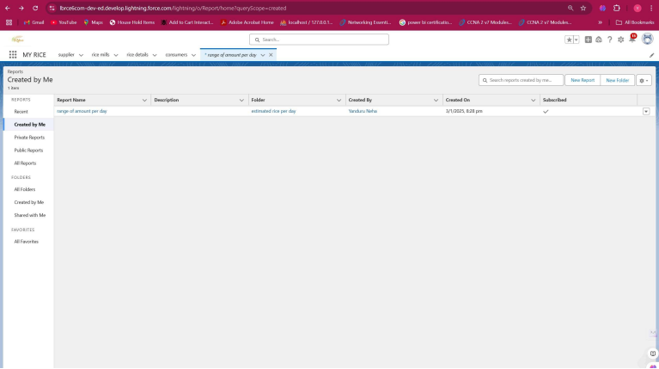

**2.Sharing report to owner**

1. Click edit drop down and select subscribe option
2. Follow as per below image.
3. After selecting the run report as a “another person”  select your personal account or whom you want to send that mail to.
4. Click save.

NOTE: The owner gets daily email notification of that rice mill report.so that he can see all data remotely.

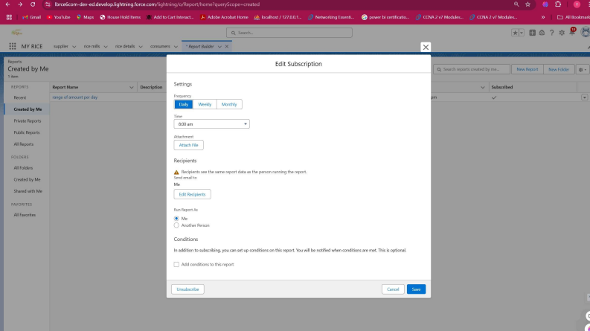

**3.create a report folder**

1. Click on the app launcher and search for reports.
2. Double click on the report,  “ reports tab” will be auto populated in the navigation bar.
3. Click on the report tab, click on the new folder.
4. Give the Folder label as “estimated rice per day ”, Folder unique name will be auto populated.
5. Click save.

1.navigate to app launcher and click reports on that.

2.click all reports.

3. Select the range of amount per day drop down in that click move.

4. Select estimated rice per day folder and select folder.

Note: if you want to see the report which you have created then go to reports - all folders - estimated rice per day - your report will appear in this way.

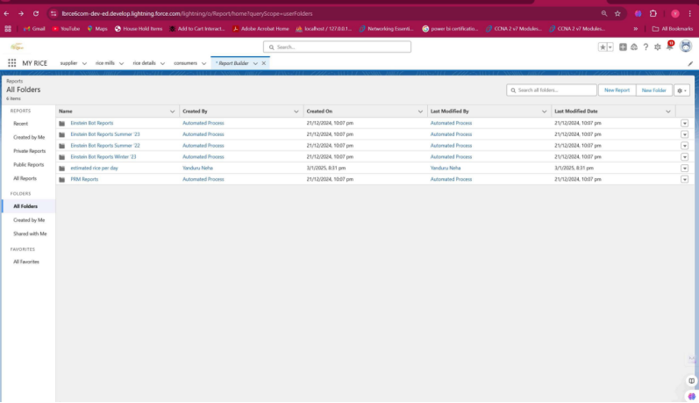

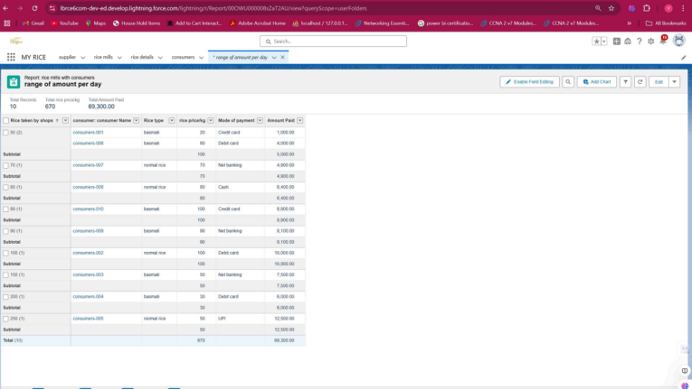

**Dashboards**

Dashboards help you visually understand changing business conditions so you can make decisions based on the real-time data you’ve gathered with reports. Use dashboards to help users identify trends, sort out quantities, and measure the impact of their activities. Before building, reading, and sharing dashboards, review these dashboard basics.

**1.Create Dashboard Folder**

1. Click on the app launcher and search for the dashboard.
2. Click on the dashboard tab.
3. Click the new folder, give the folder label as “ amount data  dashboard”.
4. Folder unique names will be auto populated.
5. Click save.

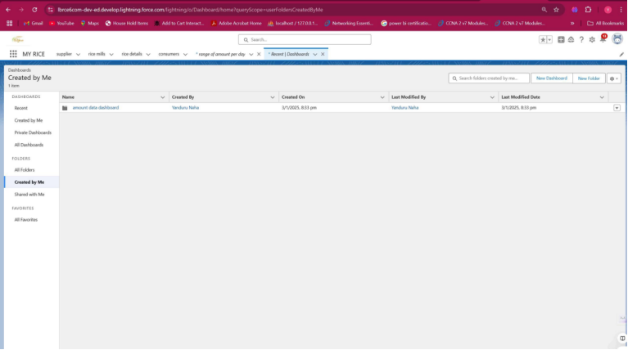

**2.Create Dashboard**

1. Go to the app >> click on the Dashboards tabs.
2. Give a Name and select the folder that was created, and click on create.
3. Select add component.
4. Select a Report and click on select.
5. Preview is shown below
6. 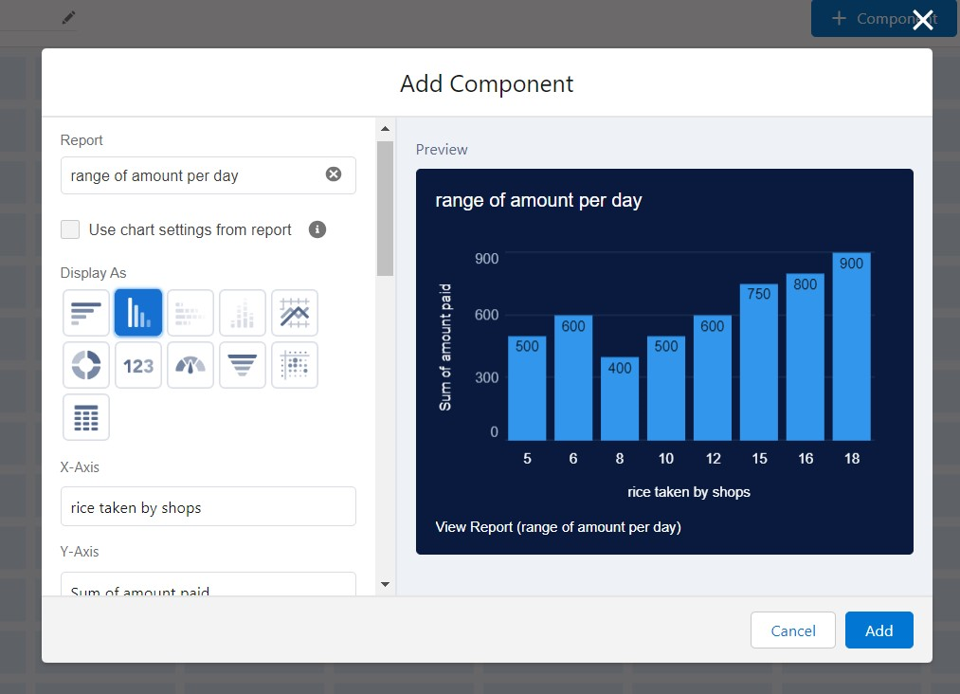

* Display as>> vertical bar chart
* X-axis >> rice taken by shops
* Y-axis >> sum of amount
* Y-axis range >> automatic
* Sort by >> rice taken by shops
* Component theme >> dark.
* Add the component

Again select add component with above same steps

* display  as donut chart
* sort by >> sum of amount
* title>>range of amount per day
* component theme dark
* Click add.
* Click save and done.

